WARKOP WARGA – SMART QR ORDERING & POS SYSTEM 2026


Members:
- Angwyn Aurelius Veicensia
- Cidan Albasith Rizqulloh
- Eprilvia
- Ghaziya Manna Putri Iwadani
- Jesseco Juander Can
- Naimah Nurramadhani Safitri
- Nico Johannes Sirait

Economic Survival 2: Gen-AI and Internship Experience/Business Project for Computer Science (M IT-2025 CLASS 4)
B.M.A.S. Anaconda Bangkara
Yosman Bustaman
2026

- BACKGROUND / IDEA BACKGROUND
Most small coffee shops in Indonesia still operate entirely manually, with verbal orders, handwritten notes, and cash-only transactions leading to frequent miscommunication, order inaccuracies, and a lack of financial traceability. Warkop Warga was developed to address this three-pronged operational barrier by offering a QR code-based digital ordering system accessible on any smartphone without the need for an app, and affordable enough for micro-businesses.
- PRODUCT SUMMARY
Product Name | Warkop Warga – Smart QR Ordering & POS System
Problems Solved | Manual ordering errors, slow service, and lack of financial records in small coffee shops.
Brief Description | A full-stack web app: customers scan a QR code at their table, browse the menu, add custom item notes, and checkout digitally. Admins manage orders and daily revenue via a live dashboard.
Main Innovation | Normalized MySQL database + real-time cashier dashboard with audio alerts + automated date-grouped bookkeeping—packaged into a zero-install, mobile-first web interface.
- PRODUCT / SERVICE DESCRIPTION
  - Operational Mechanism
Warkop Warga runs on two synchronized interfaces. The Customer Interface (index.html) activates when a customer scans the table QR code; the URL parameter (?table=xxx) auto-identifies the table. Customers browse categorized menu items, add items to a slide-out cart with per-item custom notes, select QRIS or Cash payment, and receive a digital receipt. The Admin Dashboard (admin.html) polls the backend every 3 seconds; new unpaid orders trigger a pulsing visual card and audio beep. The cashier confirms payments and views date-separated bookkeeping with automated daily revenue totals.
  - Main Components
- Frontend: HTML5, Vanilla JavaScript, Tailwind CSS (CDN), Lucide Icons, QRious library.
- Backend: Node.js + Express.js REST API, mysql2 database driver, CORS middleware.
- Database: MySQL (phpMyAdmin/XAMPP)—two relational tables: orders (transaction header) and order_items (per-item detail), linked by Foreign Key.
  - Product Documentation
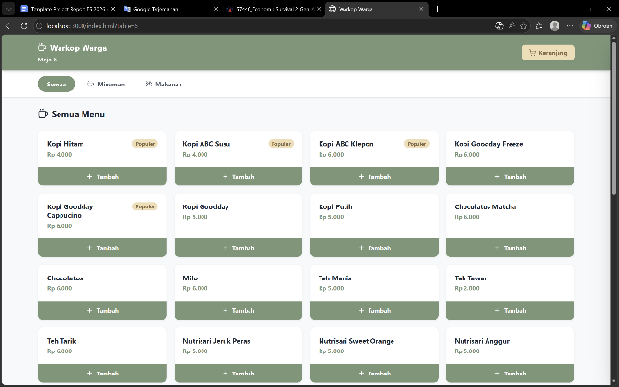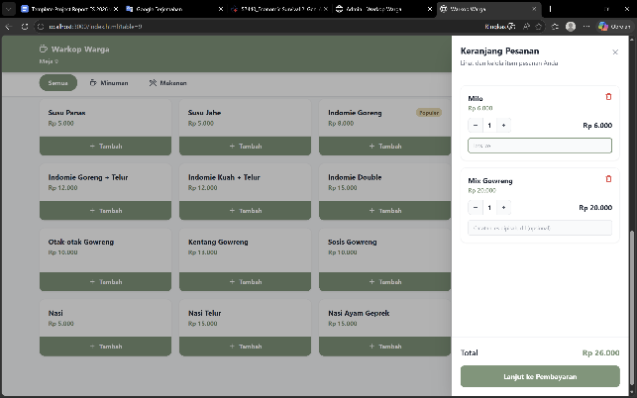
Figure 1: Main Menu Page | Figure 2: Interactive Cart & Order Customization
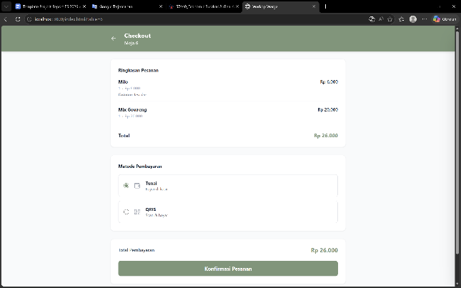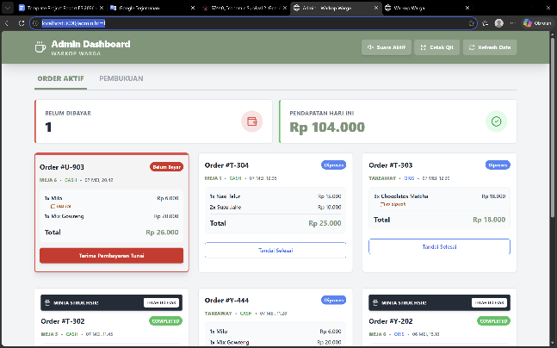
Figure 3: Checkout and Payment Selection Page | Figure 4: Admin Order Management Dashboard
- INNOVATION / NOVELTY
  - Distinction from Similar Products
- Zero App Installation: Fully browser-based—no download, no account required for customers.
- Offline-Capable on LAN: Runs entirely on a local hotspot network; no internet subscription required during operation.
- Per-Item Custom Notes: Allows item-level customization (e.g., "no sugar", "extra spicy") not available in most small-business POS tools.
- Normalized Relational Database: Two linked MySQL tables provide structured, non-redundant data—superior to spreadsheet or localStorage alternatives.
  - Primary Added Value
- Operational Efficiency: Orders appear on the admin dashboard within 3 seconds of submission, eliminating verbal relay.
- Financial Transparency: Automatic date-grouped bookkeeping with daily revenue totals replaces error-prone manual tallying.
- Physical Receipt Alert: If a customer requests a physical receipt, the order card re-appears in the Active tab with a pulsing notification.
  - Market Potential & Competitiveness
Target market: Small-to-medium local warkops and casual eateries in Indonesia. Key competitors (Moka POS, Gobiz, GrabMerchant) require monthly subscriptions (Rp 200,000–500,000/month), proprietary hardware, or stable internet. Warkop Warga is entirely free to operate post-setup—only a laptop and a free XAMPP installation are required.
- FUNCTIONALITY & TESTING
  - Core Functions
- QR Code Table Detection: Each table QR links to ?table=X, binding all orders to the correct table automatically.
- Real-Time Order Sync: Active orders appear on admin dashboard within 3 seconds via polling.
- Dual Payment Support: QRIS and Cash, with appropriate UI cues for each payment type.
- Order Status Lifecycle: Unpaid → Paid → Completed, managed by admin action buttons.
- Auto Database Seeding: On first launch with an empty database, the server injects multi-day sample data for instant demonstration.
  - Basic Testing Results
Test Case | Result
Submit order via customer interface | ✓ Appears on admin within 3 seconds
Add item note ("es dipisah") | ✓ Note shown on admin card & digital receipt
Request physical receipt | ✓ Order re-appears with pulsing alert in Active tab
Click "Aktifkan Suara" button | ✓ Audio beep plays on all subsequent orders
View Bookkeeping tab | ✓ Orders grouped by date with daily revenue totals
Server restart with empty database | ✓ Tables auto-created and sample data seeded
  - Strengths & Limitations
- Strengths: Zero-cost operation; works offline on LAN; normalized database for data integrity; mobile-first responsive design; real-time dual-screen sync.
- Limitations: Requires manual XAMPP + Node.js setup (not yet a one-click installer); polling-based sync (not true WebSocket real-time); QRIS payment currently simulated (no live merchant account).
  - Simulation
Simulation video: [Insert video link]
Source code (GitHub): [Insert GitHub repository link]
- CLOSING
  - Conclusion
Warkop Warga successfully demonstrates that micro-scale food and beverage businesses can be meaningfully modernized through accessible, zero-cost web technology. All core features—QR ordering, custom item notes, dual payment support, real-time admin sync, physical receipt alerts with audio, and date-grouped bookkeeping—have been implemented and verified. The system is fully operational and ready for live exhibition.
  - Development Potential
- Cloud Deployment: Migrate database to a cloud provider (Railway/Supabase) for internet-accessible, multi-device operation.
- Live Payment Gateway: Activate the existing /api/webhook/payment endpoint with a licensed Indonesian gateway (Midtrans/Xendit).
- WebSocket Upgrade: Replace polling with Socket.IO for push-based, zero-latency order notifications.
- Kitchen Display & Analytics: Add a kitchen-facing interface and sales analytics dashboard to increase long-term business value.
With these enhancements, Warkop Warga has strong potential to evolve from an exhibition prototype into a commercially viable, cloud-hosted SaaS product targeting Indonesia's rapidly growing micro-enterprise F&B sector.

